**Building Microservices with Database Migrations and GraphQL CRUD Endpoints**

**What do database migrations do and why are they useful?**

Database migrations are essential for managing changes to a database schema over time. They allow developers to modify tables, add or remove fields, and ensure that all instances of the database remain consistent across different environments. This is particularly useful in collaborative development, where multiple team members may need to update the schema without causing conflicts. Migrations also provide version control for database changes, making it easier to track modifications and roll back to previous versions if necessary. By automating schema updates, they reduce the risk of manual errors and ensure a smooth development process.

**How does GraphQL differ from REST for CRUD operations?**

GraphQL differs from REST in how it handles CRUD operations, offering a more flexible and efficient approach to data retrieval. Unlike REST, which relies on multiple fixed endpoints that can lead to over-fetching or under-fetching of data, GraphQL allows clients to specify exactly what data they need in a single request. This minimizes unnecessary data transfer and improves performance, especially when dealing with complex relationships between entities. Additionally, GraphQL eliminates the need for API versioning, as its schema can evolve without breaking existing queries. Overall, GraphQL provides a more streamlined and customizable way to interact with APIs compared to traditional REST architectures.

**Post Services Index.js**

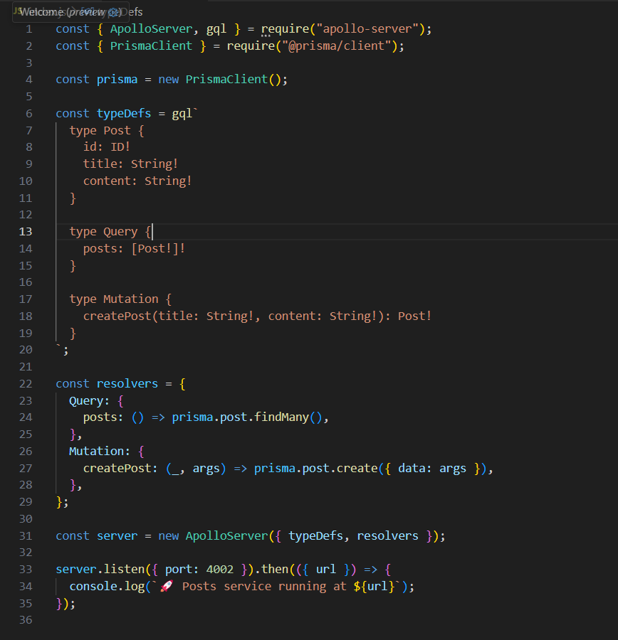

**User Services index.js**

